Infinity Moon Productions

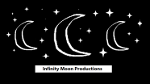
Drone Agreement / Information Packet

HELLO.
MY NAME IS:
LUNA

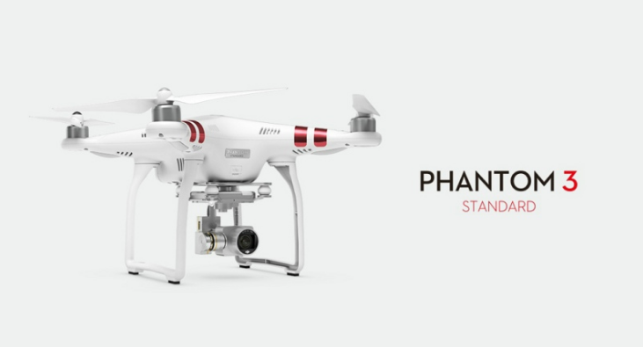

Drone Name: Luna
Drone Managers Names: JB Arbogast & Philip Arbogast
Date: 6/6/16
Prepared by: JB Arbogast

Drone Operating Agreement / Information Packet

Purpose of the Drone Operating Agreement / Information Packet

This user agreement serves as the guidelines and ground rules to help protect our actors and staff while using the DJI Phantom 3 Standard drone. The DOA is a living document and may be updated as the need arises. Any updates will be discussed with and ratified by the IMP team members.

IMP Rules & Regulations
- By agreeing to these terms you are stating that you (as a pilot) fully understand that you will be held responsible for any disobedience of these rules.
- ONLY INFINITY MOON PRODUCTIONS HAS THE AUTHORITY TO APROOVE THE PRIVILAGE TO FLY LUNA, AND THEY RESERVE THE RIGHT TO DENY ACCESS TO THE DRONE OR ITS FOOTAGE TO ANY PERSON.
- If you wish to use the drone, email the company and ask at infinitymoonmail@gmail.com
- Only IMP Staff members can be authorized to use Luna.
- Before the drone’s operation, ALL pilots must READ & UNDERSTAND the user manuals, the fundamental parts, and the critical functions of the drone.
- ALL PILOTS MUST KNOW & COMPLY WITH ALL FAA DRONE REGULATIONS (WE’RE NOT KIDDING – THIS IS VERY SERIOUS – JB WILL BE HELD LEAGALLY RESPONSIBLE FOR ANY MISTAKES A PILOT MAKES).
- IMP will not force any pilot to pay for damages caused to the drone while under their control, but may take away the pilot’s flying privileges at any time.
- ALL PILOTS CAN ONLY OPPERATE LUNA UNDER THE STRICT SUPERVISION OF JB OR PHILIP.

Consequences
- Failure to sign this form will result in the withholding of the privilege to fly the drone
- DRONE ACCIDENT:
Offence Number | Consequence
1 | If you crash the drone, you’re done. Permanently. This is very expensive equipment, so be careful.

Our FAA Registration Number
- Issued to: Joseph B. Arbogast Jr:

FA3N3YM9WF

See faa.gov for a full list of rules & regulations.

I, herby agree to ALL of the rules and regulations in this packet, and to ALL of the FAA drone guidelines, and give Infinity Moon Productions my full permission to legally use this document in the court of law, if the need arises.
(Printed Customer Name)
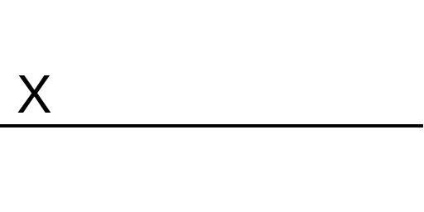
(Signed Customer Name)
Thank you for agreeing to the IMP team’s DOA!
Enjoy flying Luna, our brand new DJI Phantom 3 Standard drone!

